1. Findings
Analysis of the 24-hour telemetry sample (5,000 readings across 10 turbines) identified two units requiring urgent maintenance:
- T-04 - average temperature 90.6°C, exceeding the 85.0°C threshold. Sustained overheating indicates a cooling system fault.
- T-07 - peak vibration 25.0 mm/s, exceeding the 15.0 mm/s threshold. A single spike at this magnitude is sufficient to indicate mechanical failure risk.

The remaining eight turbines are operating within safe limits.

2. Architecture Justification
The proposed architecture replaces the single legacy server with a fully managed, event-driven AWS pipeline. The core components are:
- Amazon Kinesis Data Streams - decouples ingestion from processing. The legacy server crashed because both happened on the same machine; Kinesis acts as a durable buffer, absorbing data spikes without data loss even if a downstream component fails.
- AWS Lambda (containerised anomaly script) - the same containerised Python script from Artefact 1 runs as a stream processor, applying the anomaly rules in real time as data arrives.
- Amazon Timestream + SNS - recent readings land in a fast time-series database powering live dashboards, with SNS alerts paging engineers the moment a turbine breaches a threshold.
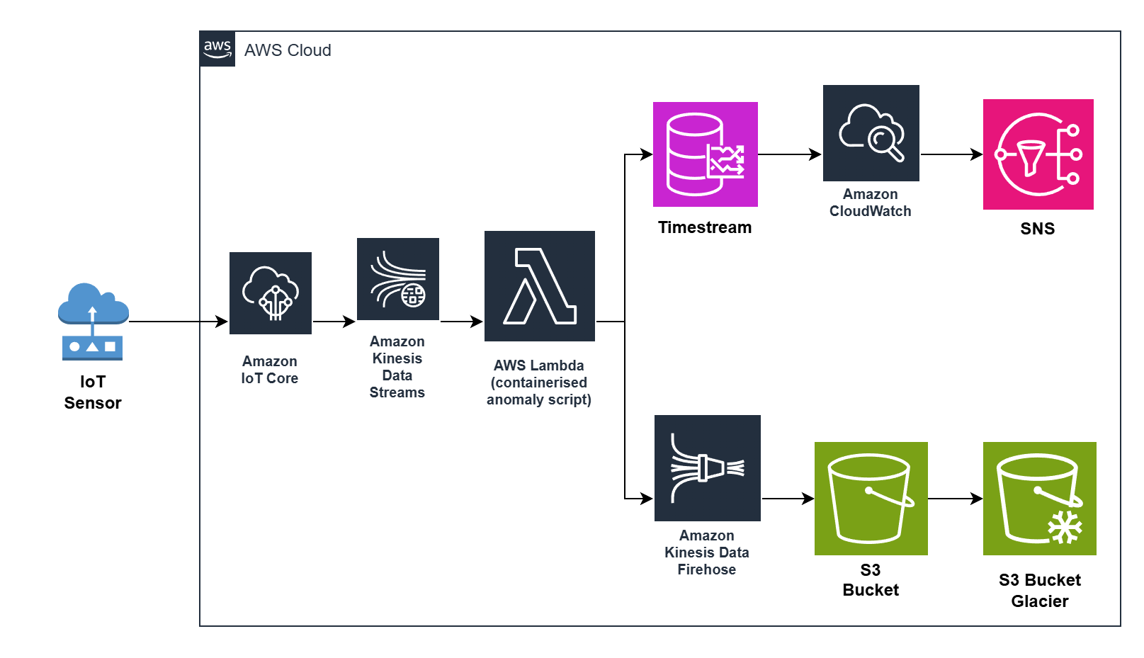
- Kinesis Firehose + Amazon S3 - all raw readings are archived in a data lake as compressed Parquet files for long-term analysis and audit.

3. Cost Optimisation

The most impactful cost reduction is tiered storage. An S3 lifecycle policy automatically transitions raw telemetry to S3 Glacier after 30 days, reducing storage costs by up to 80% on historical data. Combined with writing cold data as compressed Parquet rather than raw JSON, storage spend on a continuous high-volume pipeline is significantly reduced without losing any data

